

AGILE SPRINT PLANNING & USER STORY WORKSHOP
AI-Based Smart Cold Chain Logistics Monitoring and Optimization Platform

1. Project Vision and Stakeholders

Project Vision
To build an AI-powered, IoT-enabled Cold Chain Logistics Monitoring and Optimization Platform that delivers real-time visibility, predictive intelligence, and automated quality assurance across the temperature-sensitive supply chain — minimizing spoilage, ensuring regulatory compliance, and strengthening trust between shippers, carriers, and customers.

Project Objectives
- Continuously monitor temperature and humidity across every shipment.
- Track shipment locations in real time using GPS.
- Predict refrigeration equipment failures before they occur.
- Optimize transportation routes for time, cost, and product safety.
- Generate automated quality alerts for out-of-range conditions.
- Analyze logistics performance through actionable dashboards.
- Reduce product spoilage and associated financial losses.
- Improve end-to-end supply chain visibility and regulatory compliance.

Key Stakeholders
Stakeholder | Role / Interest
Product Owner | Owns the product vision; prioritizes the backlog and represents business/customer interests.
Scrum Master | Facilitates Agile ceremonies and removes impediments for the development team.
Development Team (IoT, Cloud & AI Engineers) | Designs and builds the sensor integration, cloud platform, and AI/ML models.
Fleet Managers / Dispatchers | Primary users who monitor shipments and act on alerts and route suggestions.
Drivers / Transport Staff | Operate refrigerated vehicles and respond to in-cab alerts.
Cold Storage & Warehouse Managers | Manage storage conditions and hand-off points in the supply chain.
Quality Assurance / Compliance Auditors | Verify environmental logs against regulatory standards (e.g., GDP, FSSAI, WHO).
Pharmaceutical & Food Manufacturers (Clients) | Shippers who depend on the platform to protect product integrity.
End Customers / Retailers / Hospitals | Receivers of shipments who require proof of quality and timely delivery.
Regulatory Bodies | Define compliance requirements that the platform must support and report against.

2. Epics and User Stories
The product requirements have been decomposed into six Epics, each broken down into detailed User Stories following the standard Agile format: "As a <user>, I want <feature>, so that <benefit>."
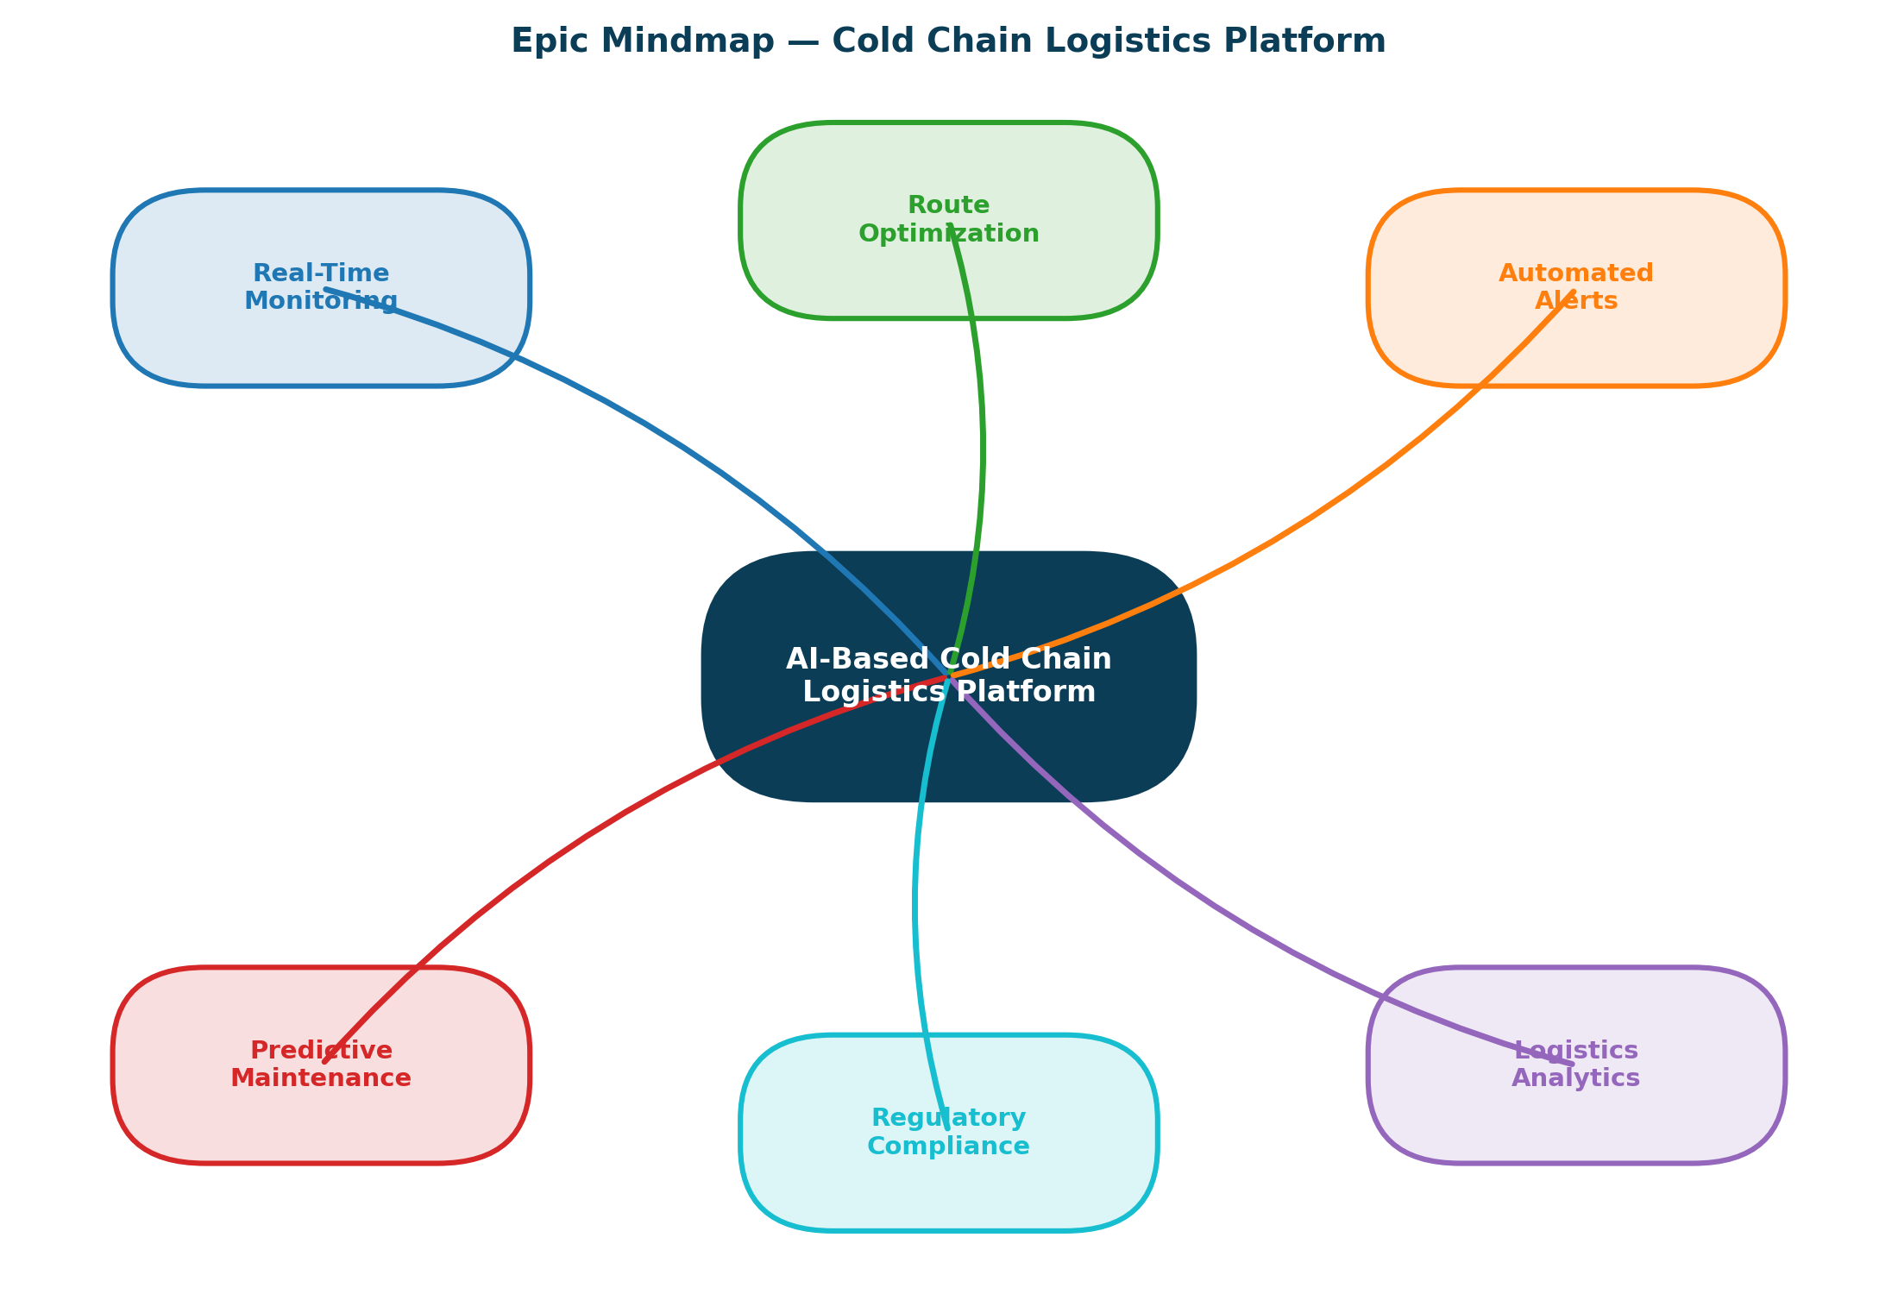

Epic 1 — Real-Time Environmental Monitoring
US-01: As a fleet manager, I want to view real-time temperature and humidity readings from each shipment, so that I can detect deviations before product quality is affected.
US-02: As a quality auditor, I want historical environmental data logged for every shipment, so that I can verify compliance during audits.

Epic 2 — GPS Shipment Tracking & Visibility
US-03: As a dispatcher, I want to track the live GPS location of every refrigerated vehicle, so that I can monitor delivery progress and estimated arrival times.
US-04: As a customer, I want to receive shipment location updates, so that I can plan receiving logistics at my facility.

Epic 3 — Predictive Equipment Maintenance
US-05: As a fleet manager, I want the system to predict refrigeration unit failures before they occur, so that I can schedule preventive maintenance and avoid spoilage.
US-06: As a maintenance technician, I want automated work orders generated from failure predictions, so that repairs happen proactively rather than reactively.

Epic 4 — AI-Driven Route Optimization
US-07: As a dispatcher, I want the system to suggest optimized delivery routes based on traffic, distance, and cold-chain risk, so that transit time and spoilage risk are minimized.

Objectives of the Proposed System
- Continuously monitor temperature and humidity of the cargo throughout transit.
- Track shipment and vehicle location in real time using GPS.
- Predict refrigeration equipment failures before they cause spoilage.
- Optimize transportation routes to reduce transit time and fuel cost.
- Generate automated quality and compliance alerts for stakeholders.
- Analyze historical logistics performance to identify recurring issues.
- Reduce product spoilage and the associated financial losses.
- Improve end-to-end supply chain visibility for all stakeholders.
Strengths and Limitations of the Current System:
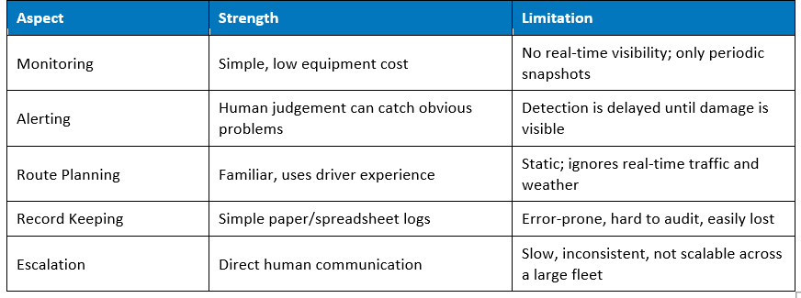

Epic 5 — Automated Alerts & Notification System
US-08: As a fleet manager, I want to receive instant alerts when temperature or humidity exceeds safe thresholds, so that I can take corrective action immediately.
US-09: As a driver, I want in-cab alerts for refrigeration malfunctions, so that I can respond without checking a separate dashboard.

Epic 6 — Analytics, Reporting & Regulatory Compliance
US-10: As a quality auditor, I want automated compliance reports generated per shipment, so that I can submit regulatory documentation quickly.
US-11: As a logistics manager, I want dashboards showing spoilage trends and performance KPIs, so that I can improve operational decisions.

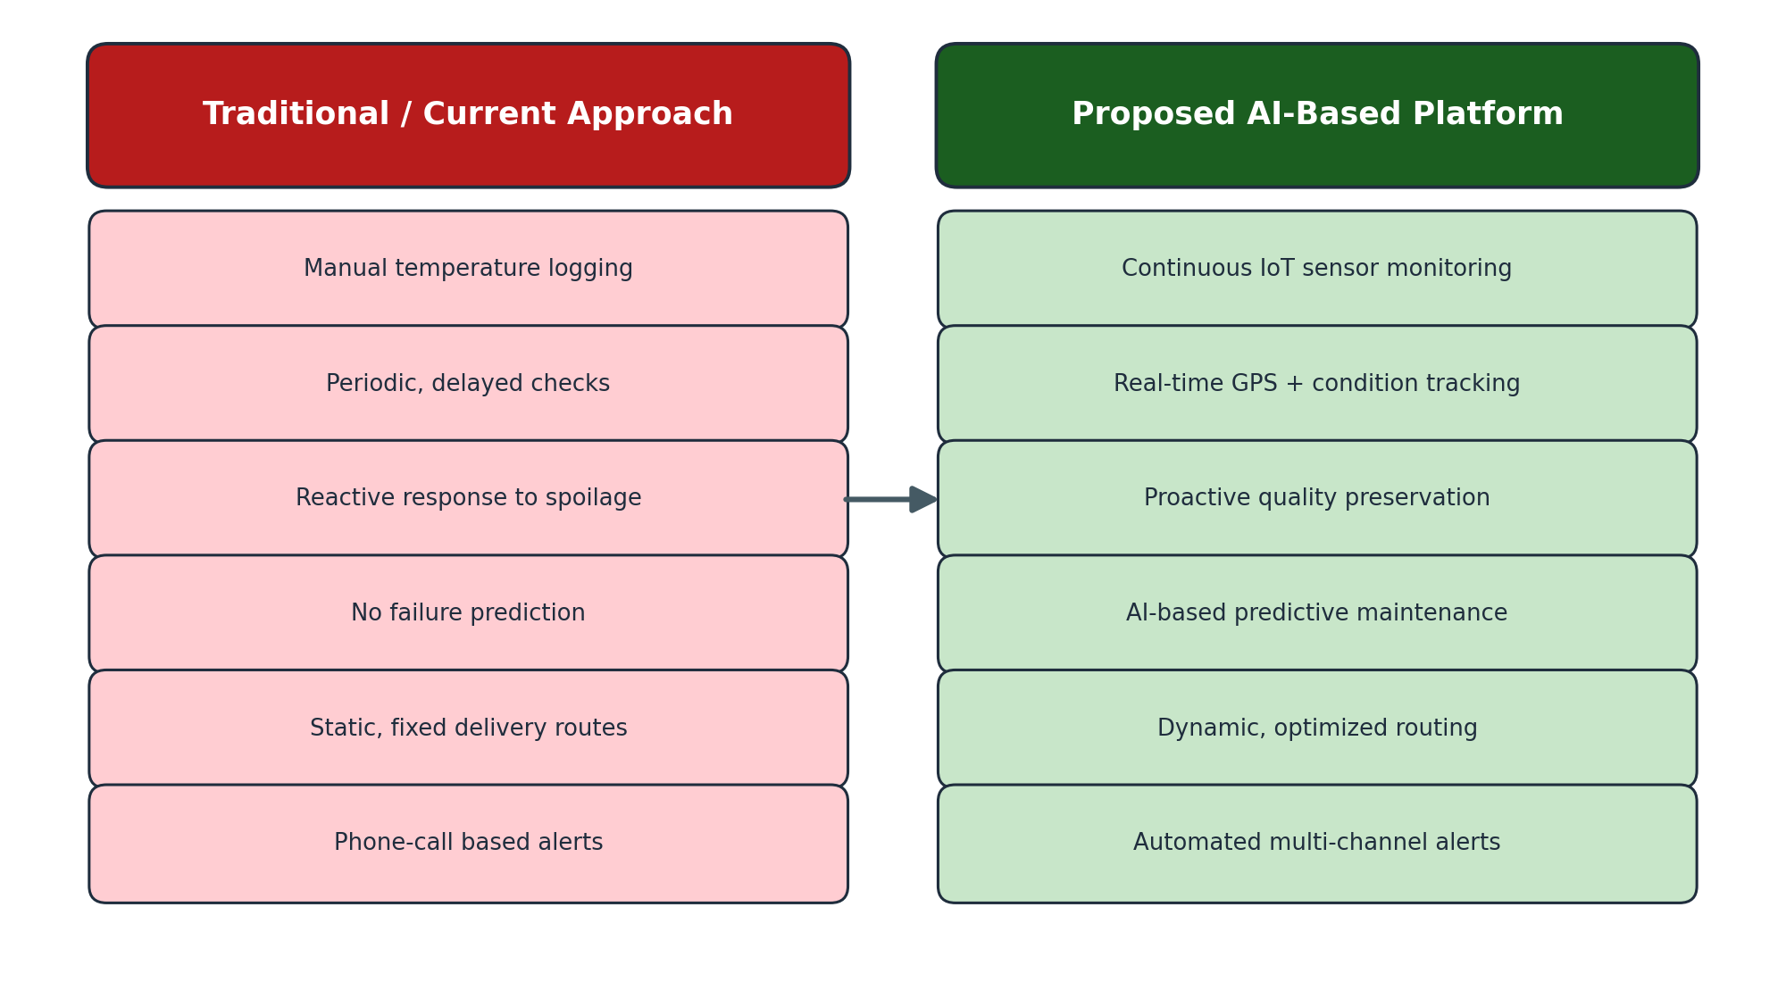

Gaps That Need to Be Addressed
- No continuous, automated sensing of temperature and humidity in transit.
- No predictive capability to flag refrigeration failures before they occur.
- No dynamic route optimization based on live traffic and cargo urgency.
- No unified, real-time dashboard accessible to all relevant stakeholders.
- No structured, tamper-proof digital record for compliance audits.

3. Acceptance Criteria
Acceptance criteria for the four user stories selected for Sprint 1, written in Given–When–Then format.

US-01: Real-Time Temperature & Humidity Monitoring
Given: a shipment is in transit with active IoT sensors,
When: a new temperature or humidity reading is captured,
Then: the reading is updated on the fleet manager's dashboard within 30 seconds and stored in the historical log.

US-03: Live GPS Shipment Tracking
Given: a refrigerated vehicle is on an active delivery route,
When: the GPS module transmits a location update,
Then: the dispatcher dashboard reflects the new position within 15 seconds, including a route-progress indicator.

US-05: Predictive Maintenance Alert
Given: historical sensor and compressor performance data exists for a refrigeration unit,
When: the AI model detects an anomaly pattern indicating a potential failure,
Then: the system generates a maintenance alert with a risk score at least 48 hours before the predicted failure.

US-08: Threshold-Based Automated Alert
Given: a shipment's recorded temperature exceeds the safe threshold defined for its product category,
When: the monitoring engine detects the deviation,
Then: an automated alert is sent to the fleet manager and driver within 60 seconds via SMS and in-app notification.

4. Product Backlog Prioritization
The backlog is prioritized using the MoSCoW technique, weighed against business value, customer needs (product safety and compliance), and technical dependencies.
# | Backlog Item | Priority | Business Value | Dependency
1 | Real-time temperature & humidity monitoring | Must Have | High | None
2 | Live GPS shipment tracking | Must Have | High | None
3 | Automated threshold-based alerts | Must Have | High | Depends on monitoring (US-01)
4 | Predictive equipment maintenance | Should Have | High | Depends on historical sensor data (US-01/02)
5 | Historical environmental data logging | Should Have | Medium | Depends on US-01
6 | AI-driven route optimization | Should Have | Medium | Depends on GPS tracking (US-03)
7 | In-cab driver alerts | Could Have | Medium | Depends on US-08
8 | Analytics dashboard & compliance reporting | Could Have | Medium | Depends on all monitoring epics

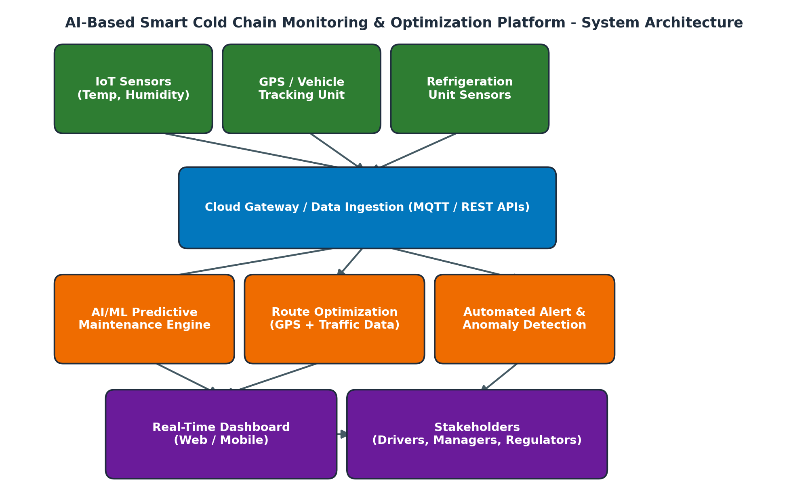

5. Sprint Backlog Planning
Sprint 1 selects the four highest-priority stories (US-01, US-03, US-08, US-05), which together establish the core monitoring and safety layer of the platform. Each story is broken down into actionable development tasks below.
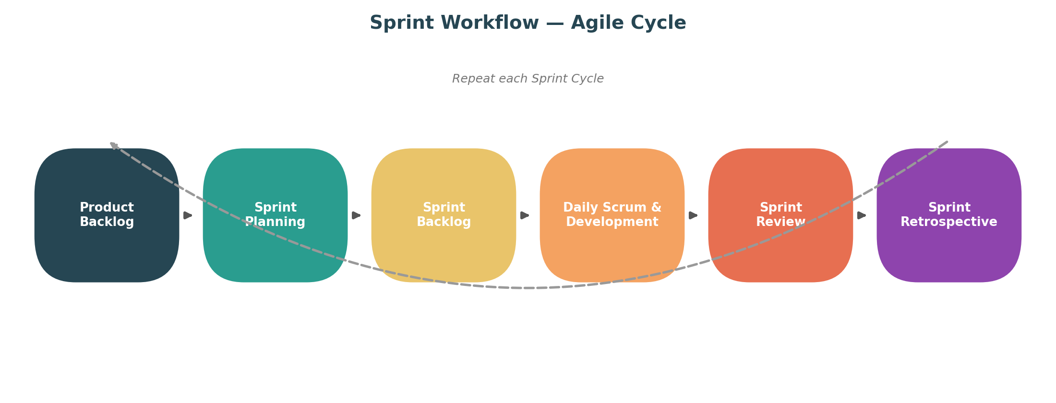

Story | Task | Owner
US-01 | Configure IoT sensor data ingestion API | Backend Dev
US-01 | Build real-time dashboard widget for temperature/humidity | Frontend Dev
US-01 | Implement historical data storage schema | Backend Dev
US-03 | Integrate GPS module data feed | IoT Engineer
US-03 | Render live map with vehicle position | Frontend Dev
US-08 | Define threshold rules engine per product category | Backend Dev
US-08 | Implement SMS/app alert notification service | Backend Dev
US-05 | Collect and label historical compressor/sensor data | Data Scientist
US-05 | Train baseline predictive-maintenance model | ML Engineer
US-05 | Integrate risk-score alert into dashboard | Full-stack Dev

How Agile Supports Development and Maintenance
Because each sprint produces a working, testable module, defects and misaligned requirements are caught early rather than at the end of a long development cycle. Once deployed, the same sprint cycle supports ongoing maintenance: sensor firmware updates, ML model retraining as spoilage patterns evolve, and dashboard refinements based on stakeholder feedback can each be handled as future sprints without disrupting the rest of the system. This keeps the platform continuously improvable over its operational lifetime, which is essential for a system that depends on a predictive model whose accuracy must be maintained over time.

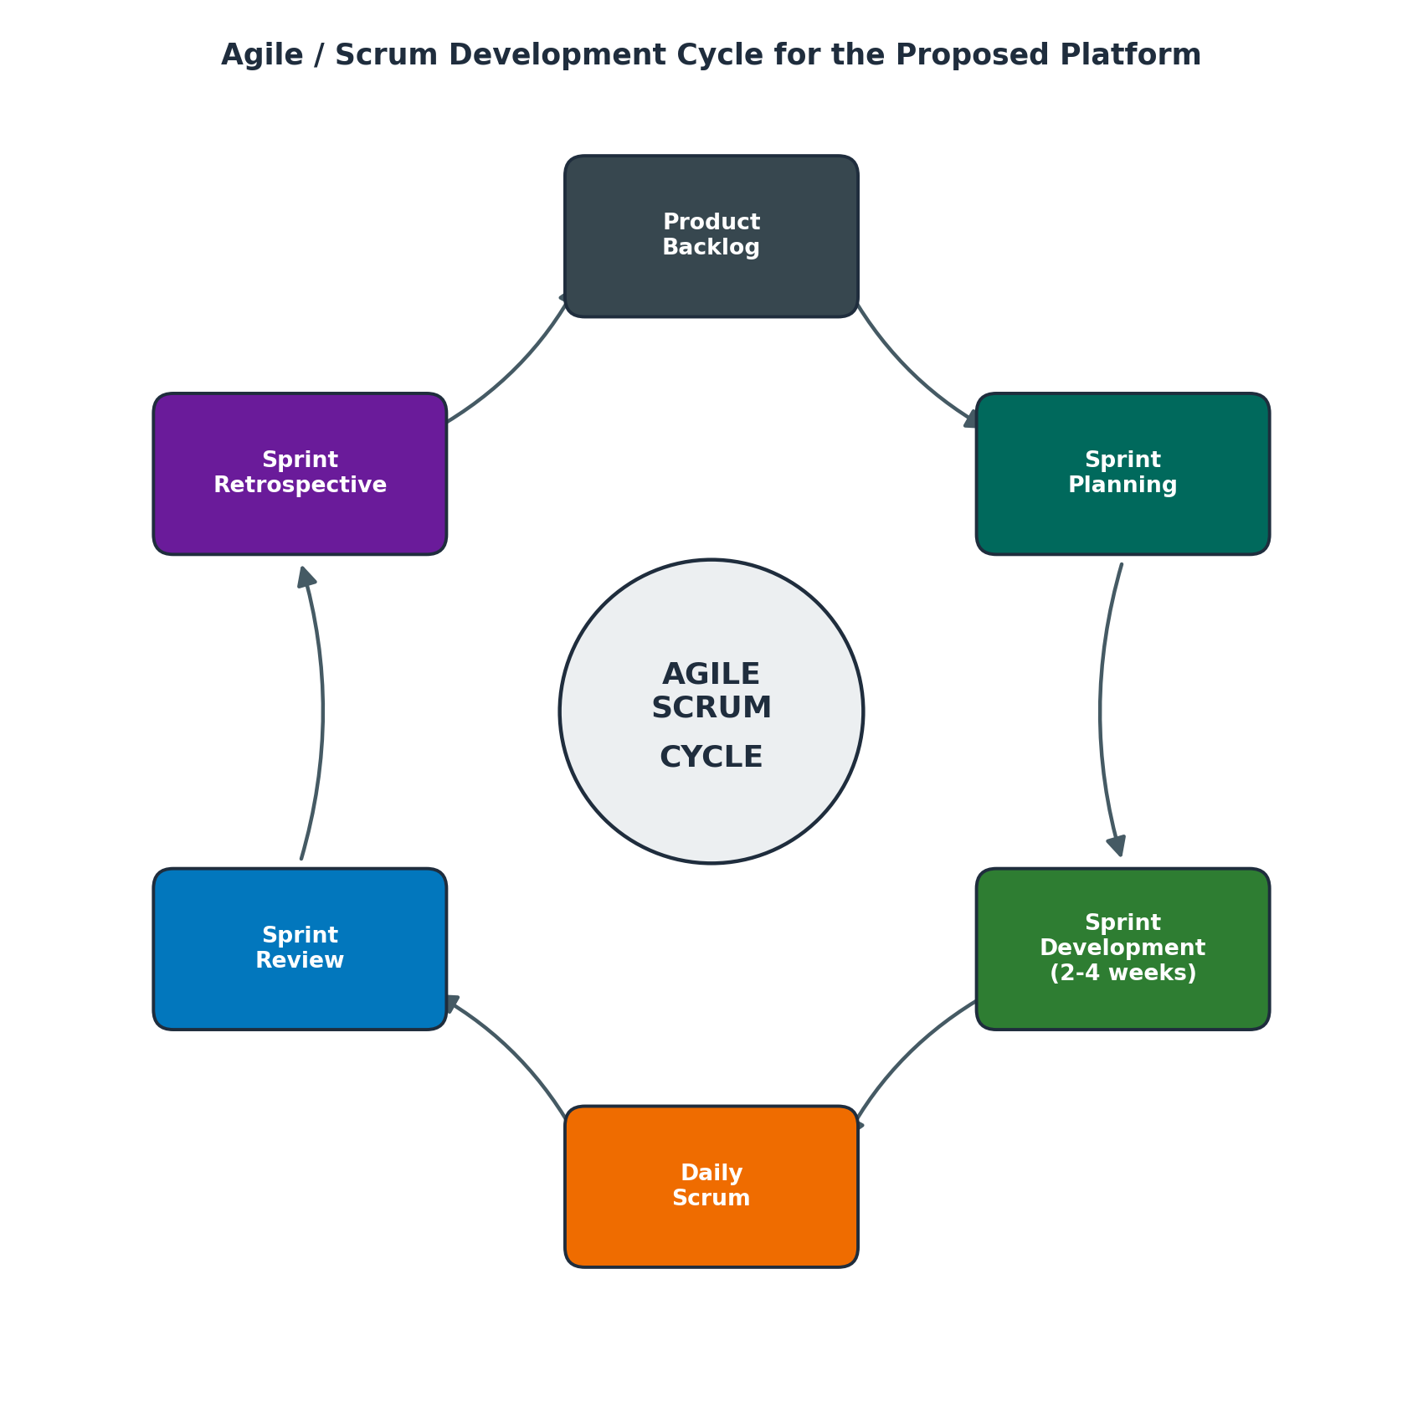

6. Story Point Estimation
Story points were assigned using Planning Poker with the Fibonacci sequence (1, 2, 3, 5, 8, 13...), reflecting relative effort, complexity, and uncertainty rather than absolute time.
Story | Title | Points | Justification
US-01 | Real-time temperature & humidity monitoring | 5 | Moderate complexity: requires a stable ingestion pipeline and real-time dashboard update, but relies on well-understood sensor protocols.
US-03 | Live GPS shipment tracking | 5 | Similar complexity to US-01 — live map rendering and periodic location updates; some uncertainty around GPS signal reliability in transit.
US-08 | Threshold-based automated alerts | 3 | Lower complexity: builds directly on US-01 data; mainly rule evaluation and notification dispatch.
US-05 | Predictive maintenance model | 8 | High complexity and uncertainty: requires historical data preparation, model training/validation, and integration — significant unknowns in data quality.

7. Sprint Goal and Expected Deliverables

Sprint Goal
By the end of Sprint 1, the platform will provide real-time temperature and humidity monitoring, live GPS shipment tracking, automated threshold-based alerts, and an initial predictive-maintenance risk model for refrigeration units — establishing the core visibility and safety layer of the Cold Chain Logistics Platform.

Expected Sprint Deliverables
- A working IoT data-ingestion pipeline streaming live sensor readings to the cloud.
- A real-time fleet manager dashboard displaying temperature, humidity, and GPS location.
- An automated alert service (SMS/app) triggered by threshold breaches.
- A baseline predictive-maintenance model producing risk scores for refrigeration units.
- A demo-ready increment presented at the Sprint Review to stakeholders.

System Architecture Overview
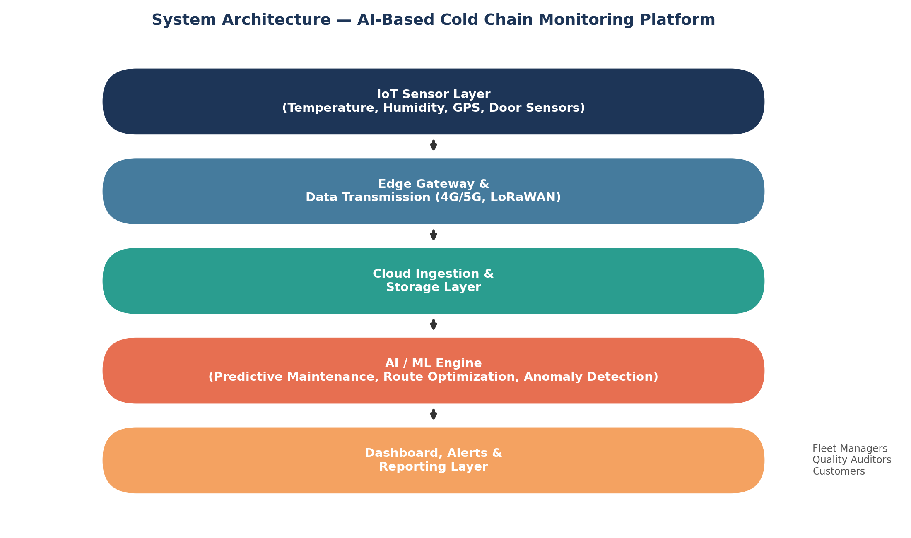

Conclusion
This sprint plan translates the AI-Based Smart Cold Chain Logistics problem statement into an actionable, prioritized backlog and a focused first sprint. Delivering core monitoring, tracking, and alerting capabilities first establishes the safety-critical foundation on which predictive analytics, route optimization, and compliance reporting will be layered in subsequent sprints.

